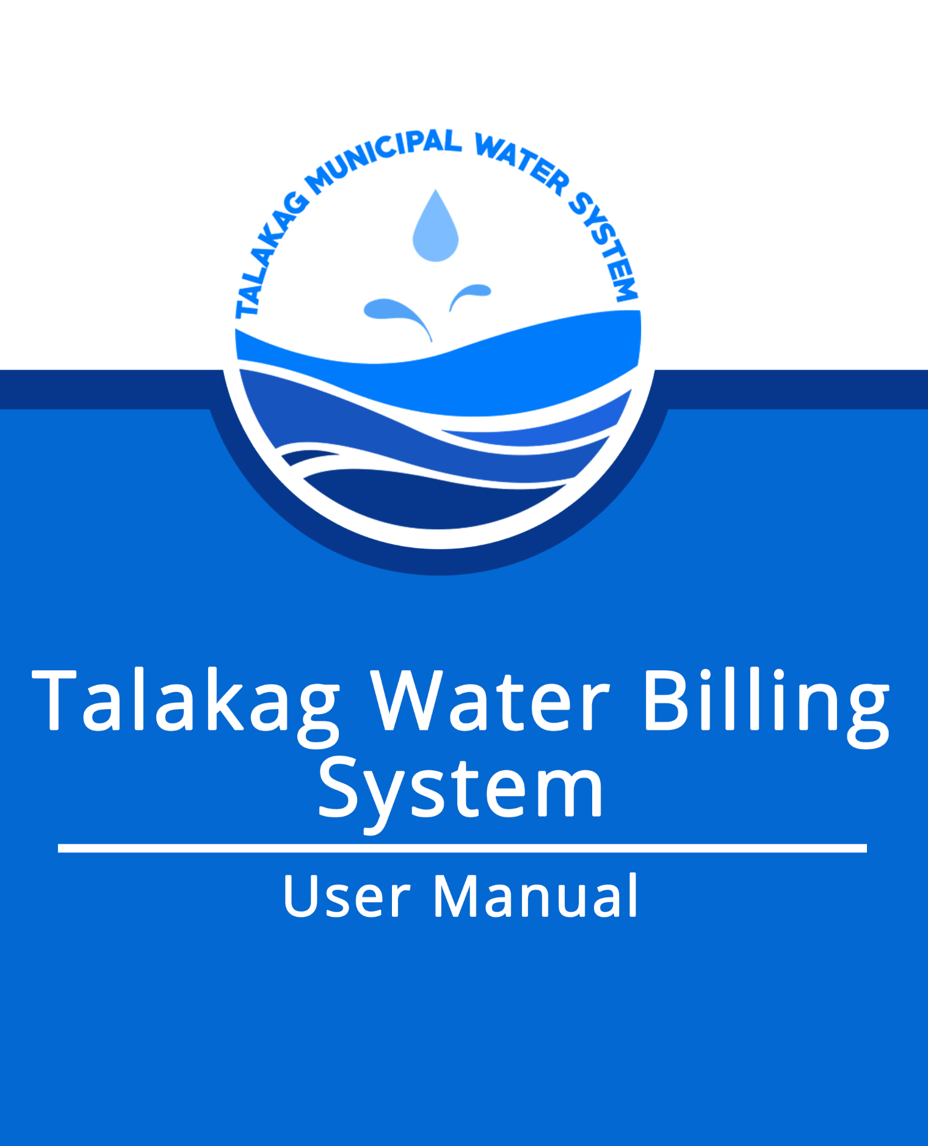

Introduction

The system is exclusively made for the Talakag Municipal Water System’s use. It will contain consumer profiles, showing their basic information, filtered by residential or commercial consumers. It will include each consumer’s transaction history; consumption (water meter readings) and payments.

This system was proposed to have a fast and precise profiling and transaction recording system for the Talakag Municipal Water System. This will allow them to properly monitor each consumer’s transaction status, to provide billings on time and disconnections when necessary. The system can also provide information as a basis of development and innovation of their current water meter reading calculation and water supply.

**Table of Contents**

1. How to install XAMPP
   * 1. How to start XAMPP Command Panel?
2. How to open localhost
   * 1. How to transfer waterbilling.sql in localhost?
3. Login Page
   * 1. How to log in?
4. Home Page
   * 1. Billing Page
        1. How to add bills
           1. Residential Billing
           2. Commercial Billing
        2. How to print bills
           1. Residential Billing
           2. Commercial Billing
        3. How to delete bills
           1. Residential Billing
           2. Commercial Billing
     2. Clients Page
        1. How to add Clients
           1. Residential Clients
           2. Commercial Clients
        2. Edit Clients
           1. Residential Clients
           2. Commercial Clients
        3. How to Delete Clients
           1. Residential Clients
           2. Commercial Clients
     3. User Page
        1. How to add Users
        2. Edit User
        3. How to Delete Users
5. Logout
6. **How to Install XAMPP**

XAMPP is a [free and open source](https://en.wikipedia.org/wiki/Free_software) [cross-platform](https://en.wikipedia.org/wiki/Cross-platform) [web server](https://en.wikipedia.org/wiki/Web_server) [solution stack](https://en.wikipedia.org/wiki/Solution_stack) package developed by Apache Friends. Since most actual web server deployments use the same components as XAMPP . it makes transitioning from a local test servers to a live server extremely easy as well.

Steps on installing XAMPP to your PC:

* Open CD or DVD drive from my Computer. And Install the program, and click on "RUN".

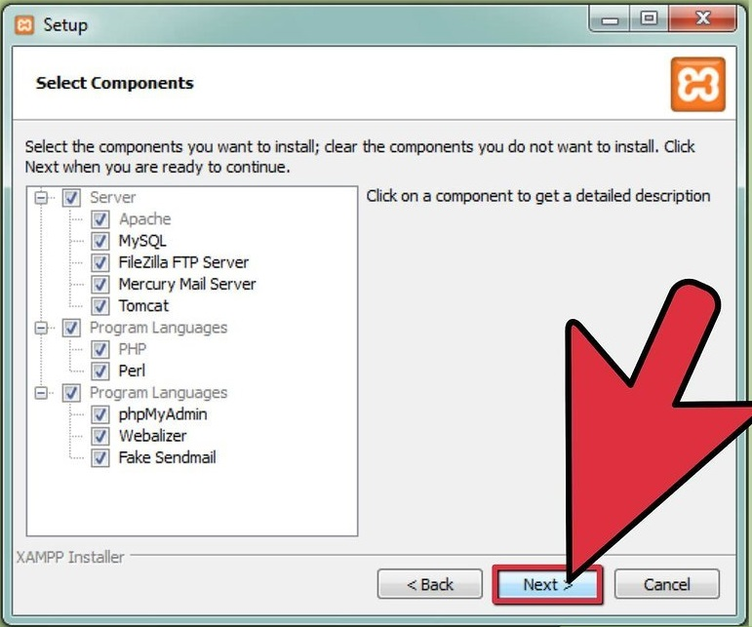

* Wait until it finished installing, the click the “Finish” button.

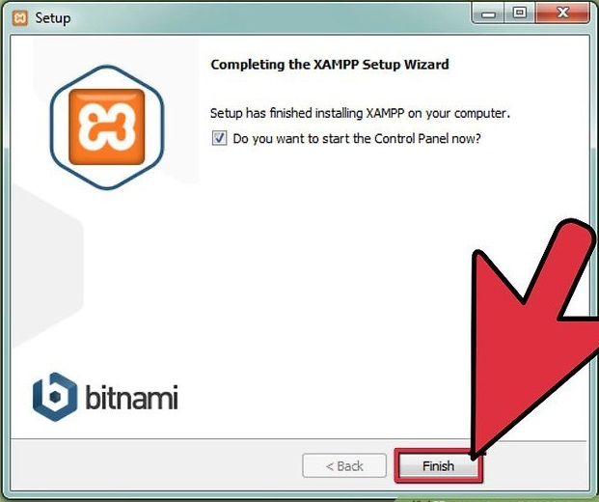

* + 1. How to start XAMPP Control Panel?
* Start the XAMPP control panel.

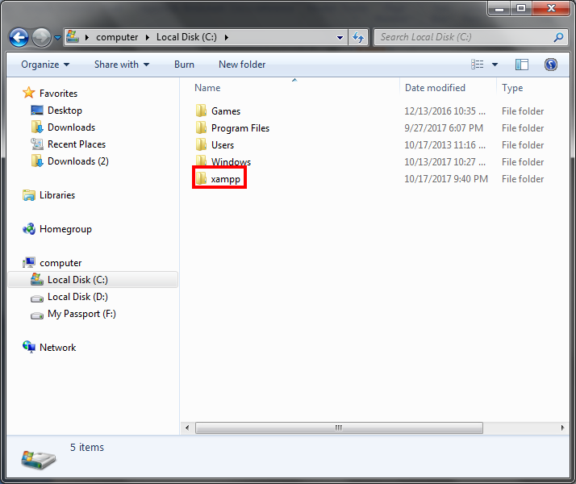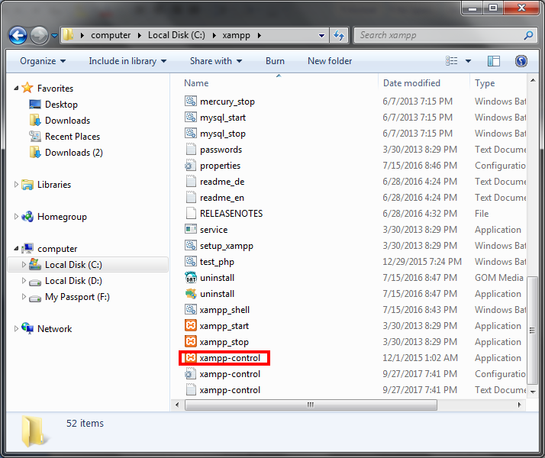

* Start the Apache and MySQL components

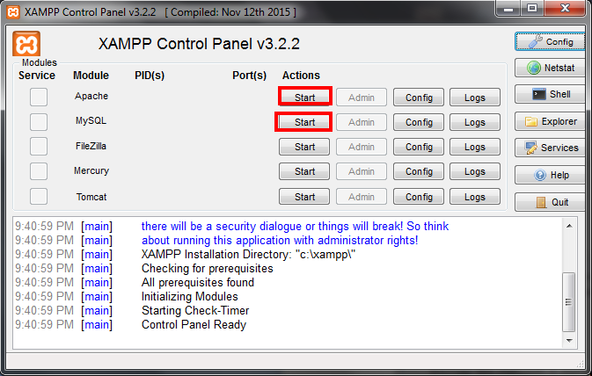

1. **How to open localhost?**

In computer networking, localhost is a hostname that means this computer. It is used to access the network services that are running on the host via its loopback network interface.

* On any search engine, go to this website “localhost/phpmyadmin/index.php”.it will bring you to its website.

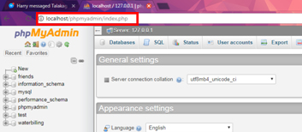

i. How to transfer waterbilling.sql in Localhost?

* On the side navigation bar and click the “New” button to create a new database and name it as “waterbilling”.

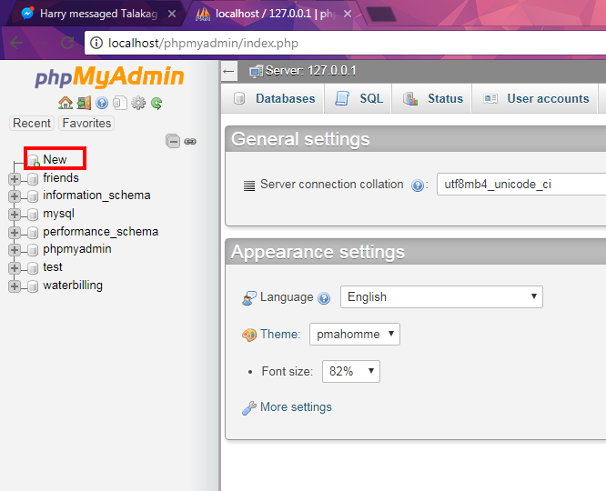

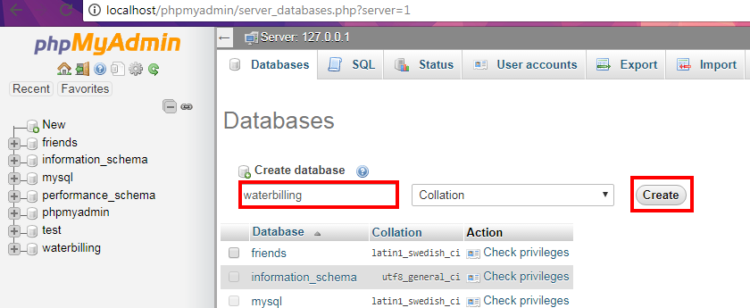

* And click on the new database and then on the upper navigation bar click on the button “Import”.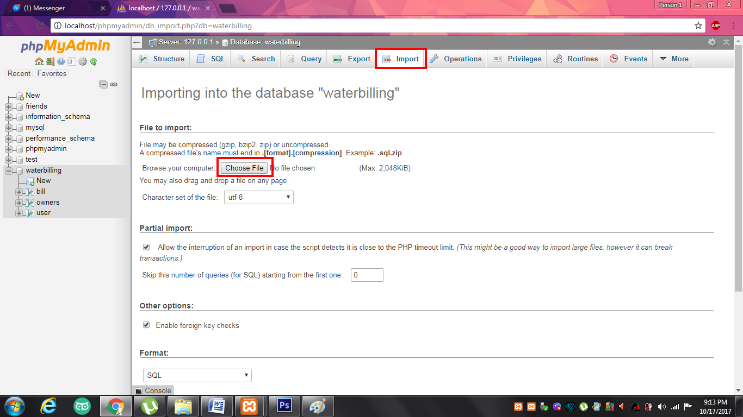
* On the import page click the “Choose File” button. And a file explorer will pop up, and double click the file “waterbilling.sql” on the installer Disk file. And click on the “Go” button which is found below.

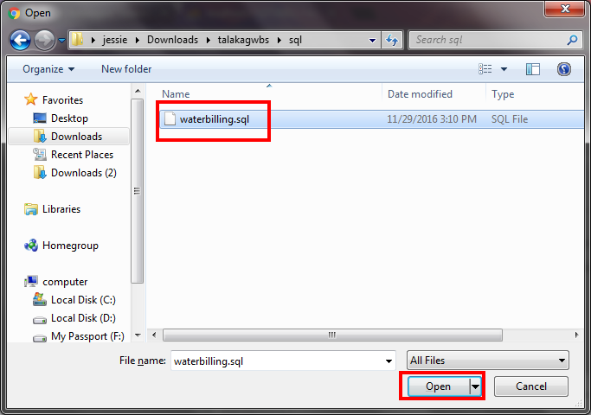

* After importing the “waterbilling.sql” wait for the conformation. 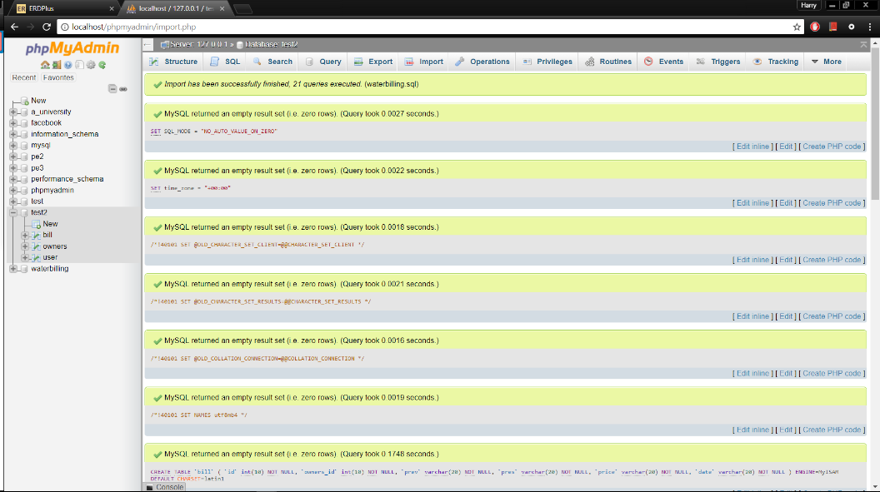
* After conforming proceed to enter on the search “localhost/wbs” and click enter.

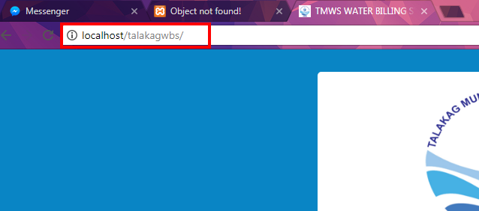

1. **Login Page**

Whenever a site access that uses the built-in administration design is accessed for the first time, the log in page will be displayed.

This page provides a security mechanism that prevents unauthorized users from accessing the system.

In order to get past the log in page, the visitor must provide a valid username and password.

The Login Page

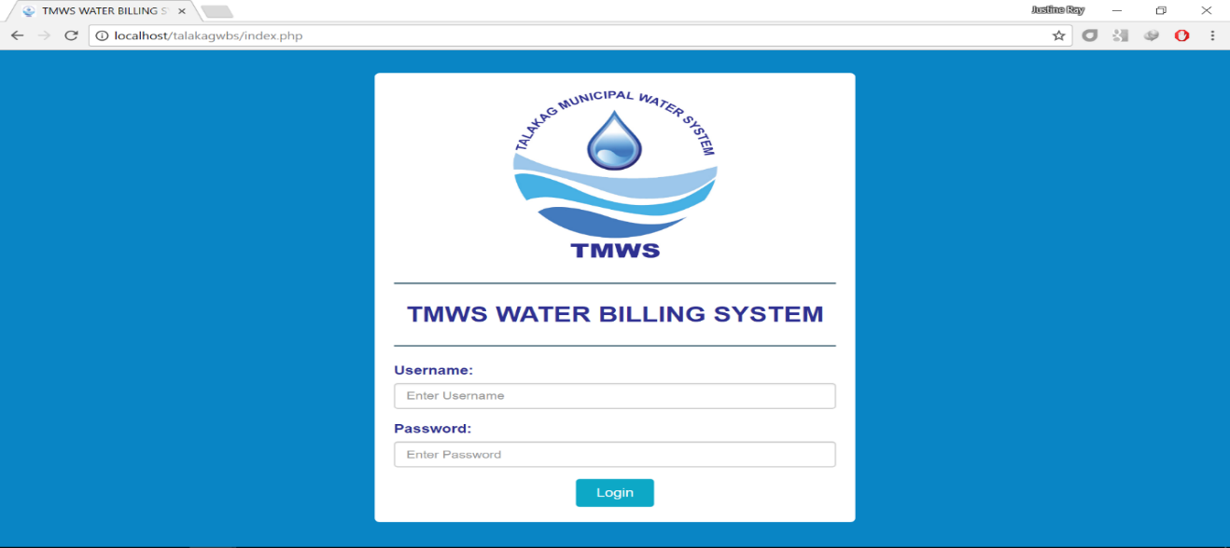

1. How to Login?

The user must provide the following information on the screen:

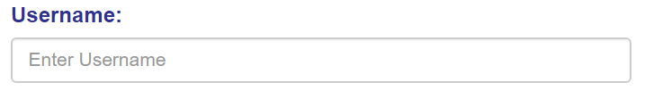

Enter a valid Username. The default Username is “**ADMIN**”

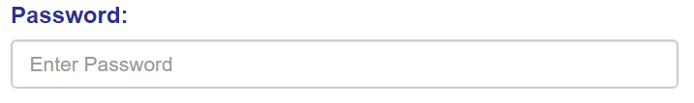

Enter a valid Password. The default Password is “**ADMIN**”

The Login Button:

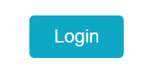

After typing the correct Username and Password, click on the Login Button.

In case the information provided (Username or Password) is not valid, the following message will be shown: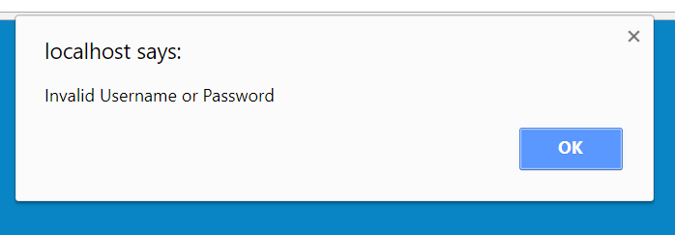

A failed to Login Message

In this instance please refer to the default Username and Password.

1. **Home Page**

After you enter the necessary information on the Login page, you will enter the Home Page. It will be displayed as.

The Home Page

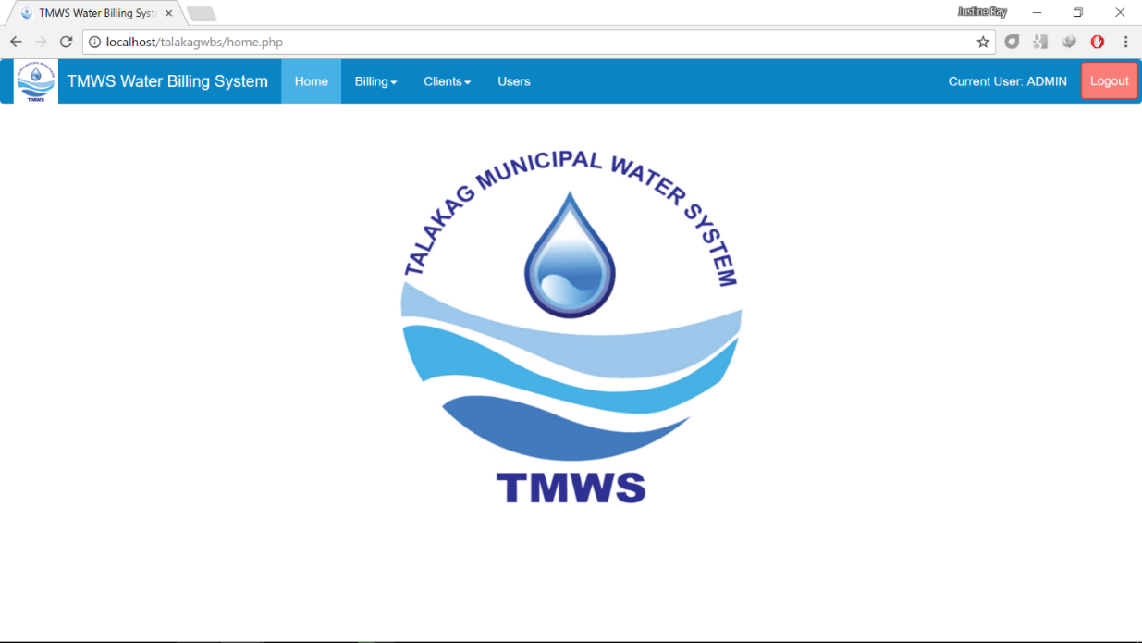

1. Billing Page

The Billing Page helps the user monitor the bills of the clients, the user can look at the Residential Billing and the Commercial Billing on its drop box menu.

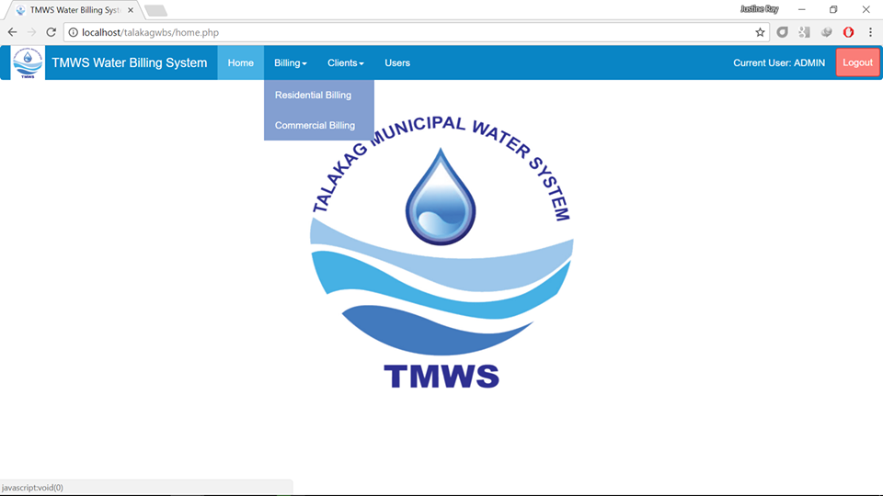

1. How to Add Bill?
   1. Residential Billing

* On add a bill on your client click the Billing Button on the upper part of the Home Page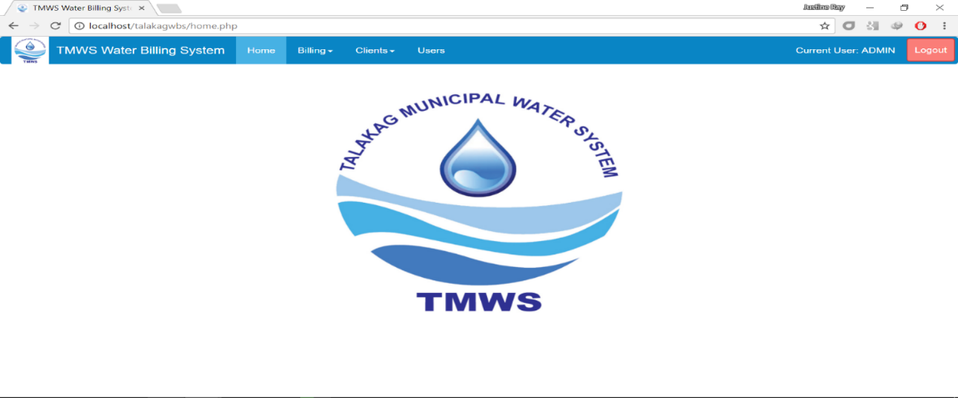
* A Drop Box will appear and click on the Residential Billing ButtonAfter click the Residential Billing button you will bring to its page.

The Residential Billing Page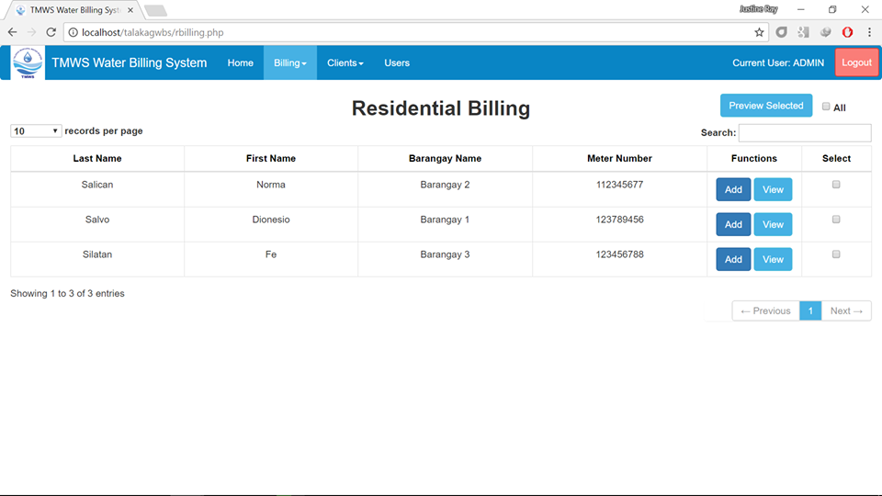

* On Adding bills on your client just click on the “Add” button on the Functions table.

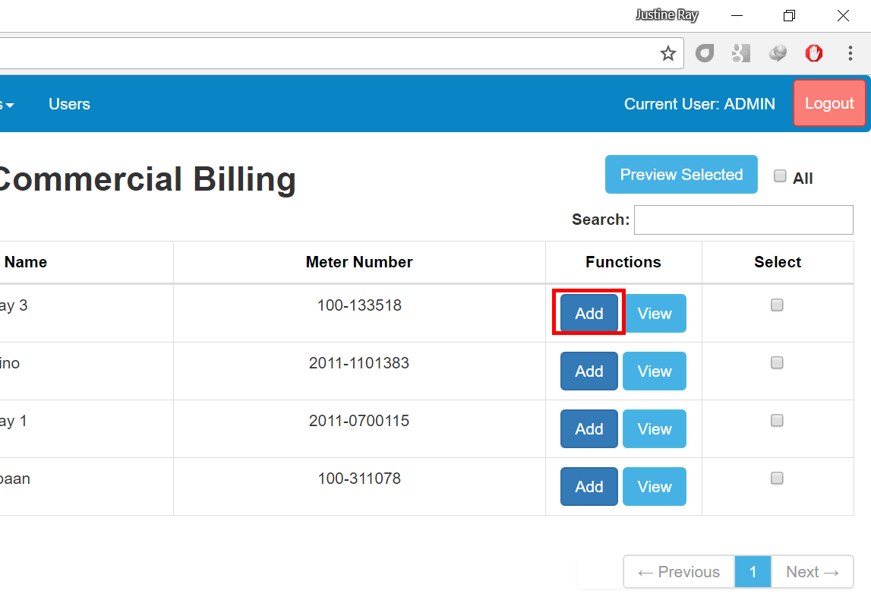

* To view the Bills on your client, click on the view button.

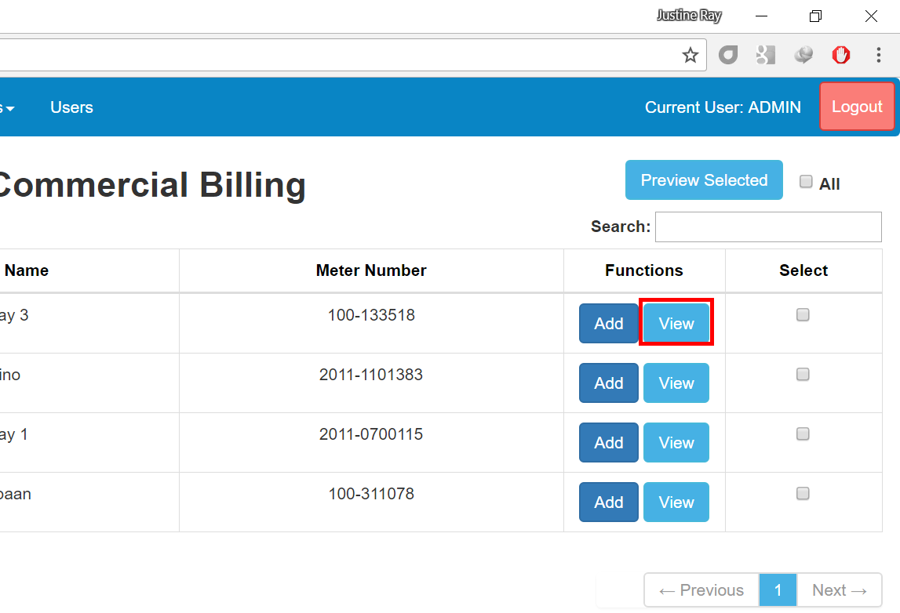

* On the view button you can Preview, Edit, or Delete the Bill. You can found it on the Functions table.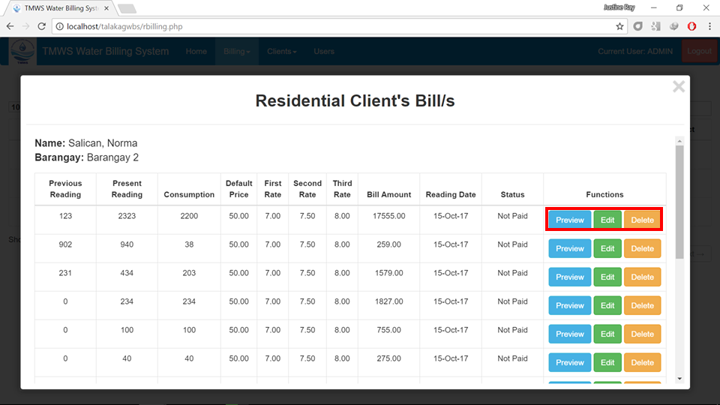
  1. Commercial Billing
* On add a bill on your client click the Billing Button on the upper part of the Home Page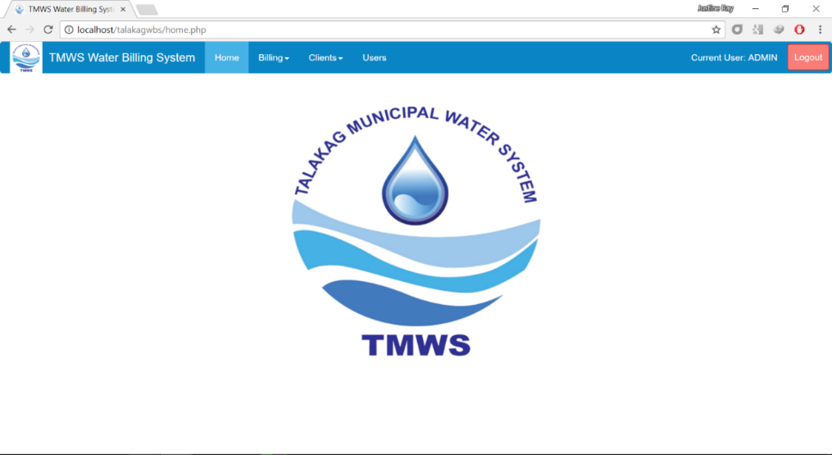
* A Drop Box will appear and click on the Commercial Billing Button. 
* After click the Commercial Billing button you will bring to its page.

The Commercial Billing Page

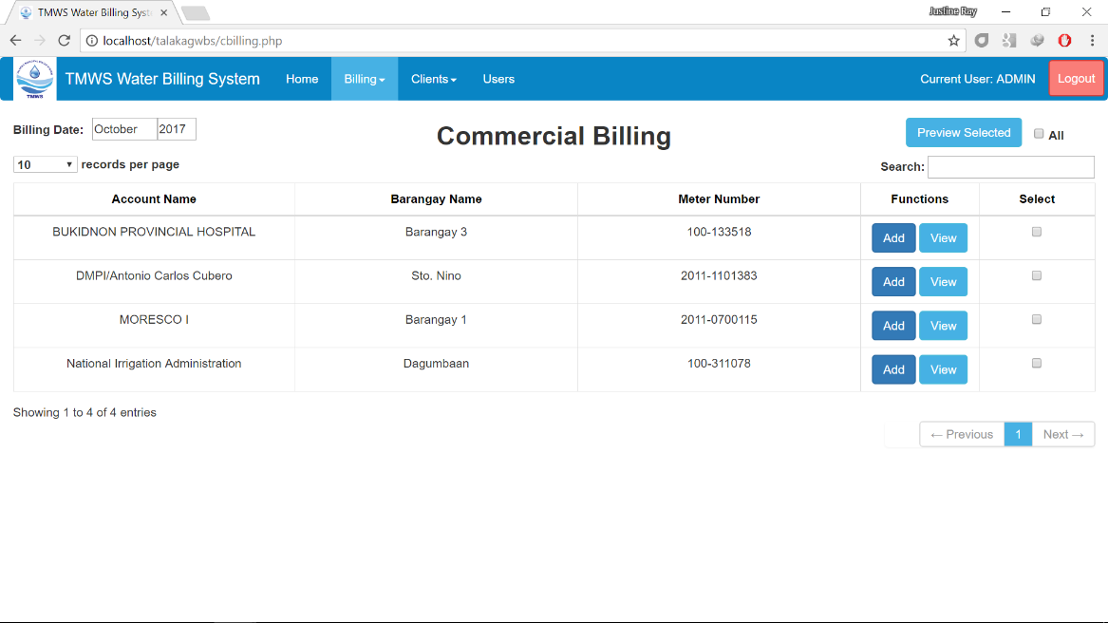

* On Adding bills on your client just click on the “Add” button on the Functions table.



* To view the Bills on your client, click on the view button.



* On the view button you can Preview, Edit, or Delete the Bill. You can found it on the Functions table.

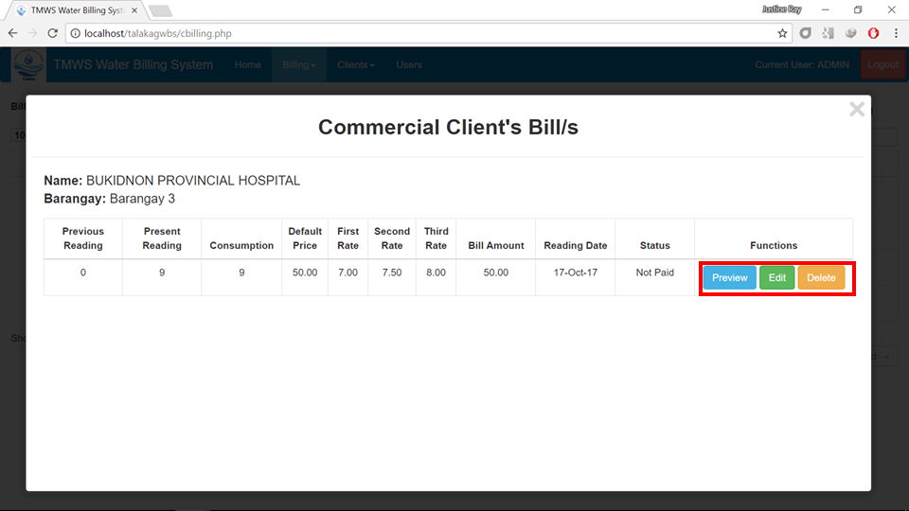

1. How to print bills
   1. Residential Billing

* As the user view on the bills of client, the user can print it by clicking on the “Preview Button”.

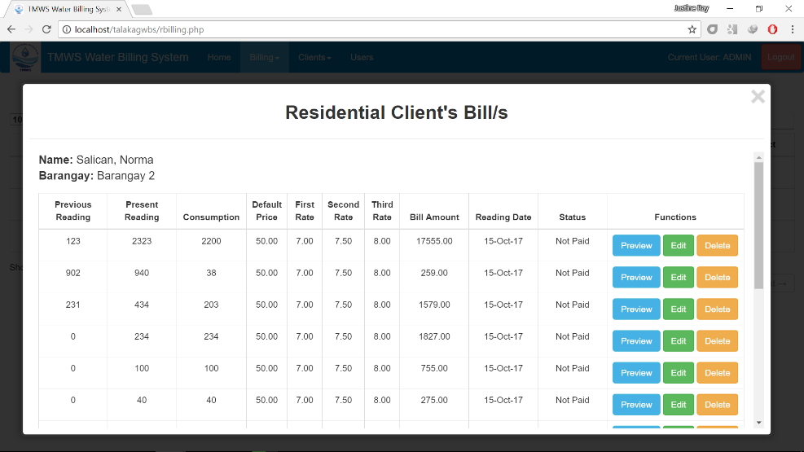

* On the bottom of the Preview Page click on the “Print Page” button to print the bill.

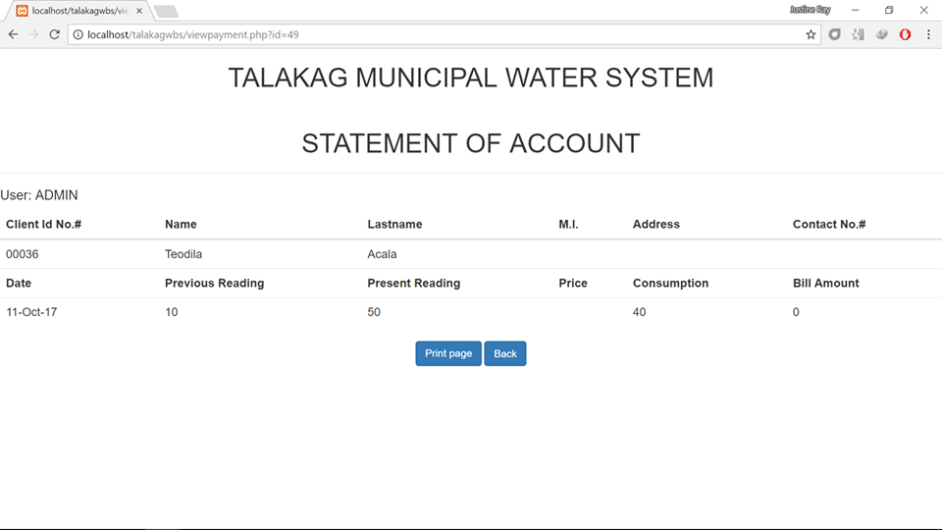

* 1. Commercial Billing
* As the user view on the bills of client, the user can print it by clicking on the “Preview Button”.

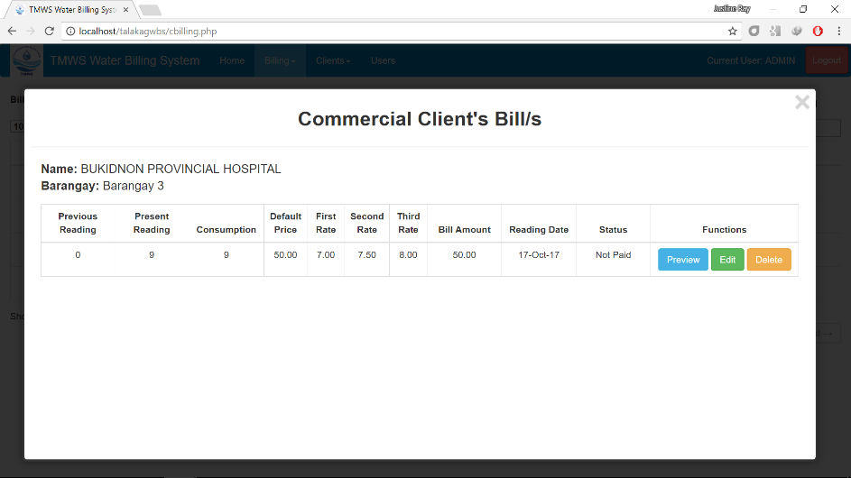

* On the bottom of the Preview Page click on the “Print Page” button to print the bill.



1. How to delete bills
   1. Residential Billing

* As the user view on the clients bill, the user can delete it by clicking on the “Delete” button.

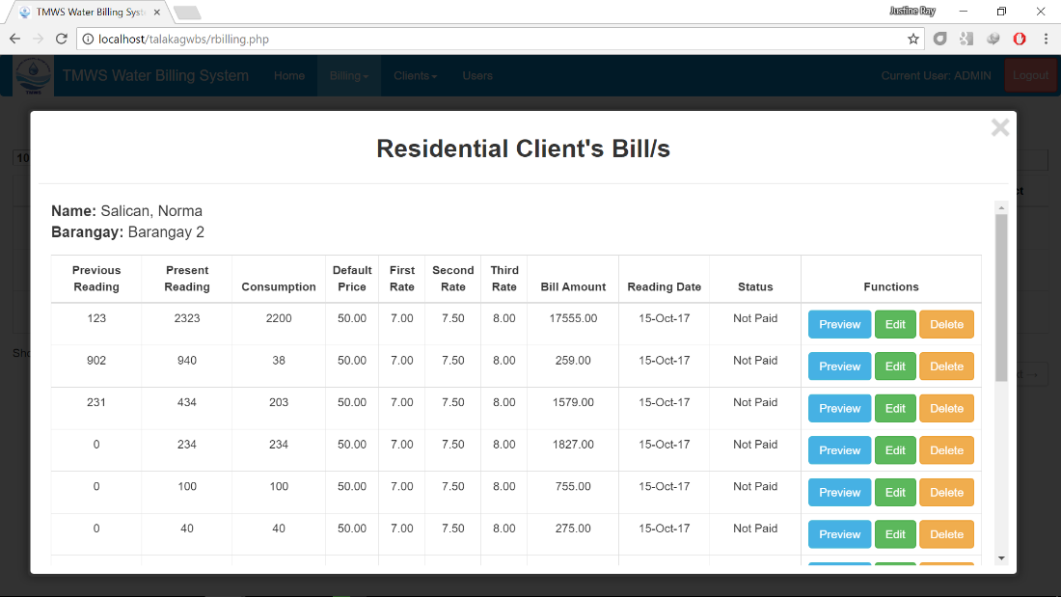

* 1. Commercial Billing
* As the user view on the clients bill, the user can delete it by clicking on the “Delete” button.

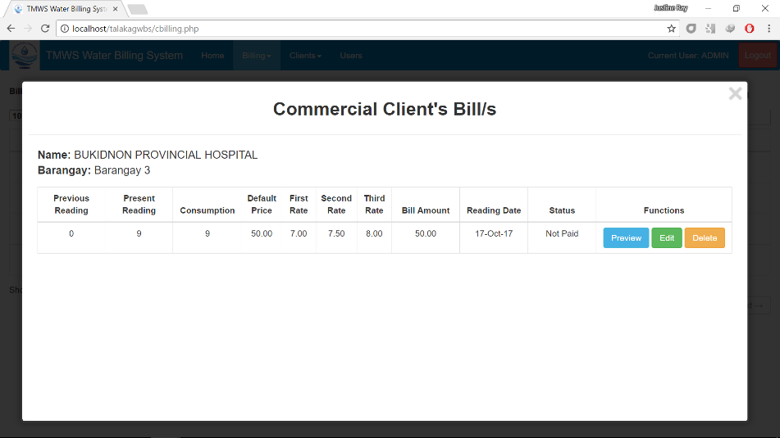

1. Clients Page

The Clients Page helps the user to hold the information on the old and new Clients. The user can look at each of the clients on the drop box below ( Residential Clients and Commercial Clients).

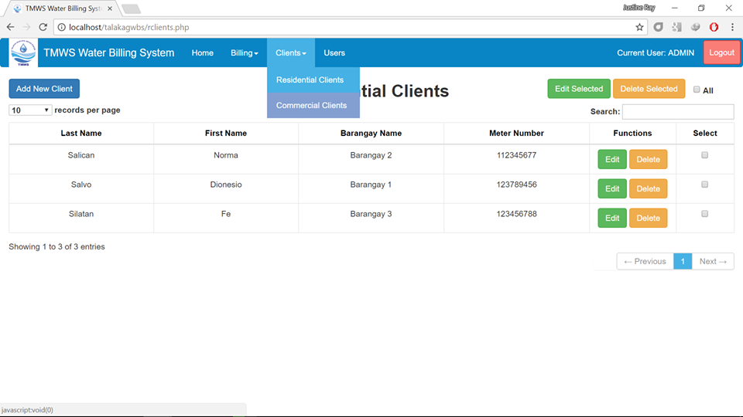

1. How to add clients
   1. Residential Client

* On adding clients , click on the “Add New Client” button found on the upper most part of the page.

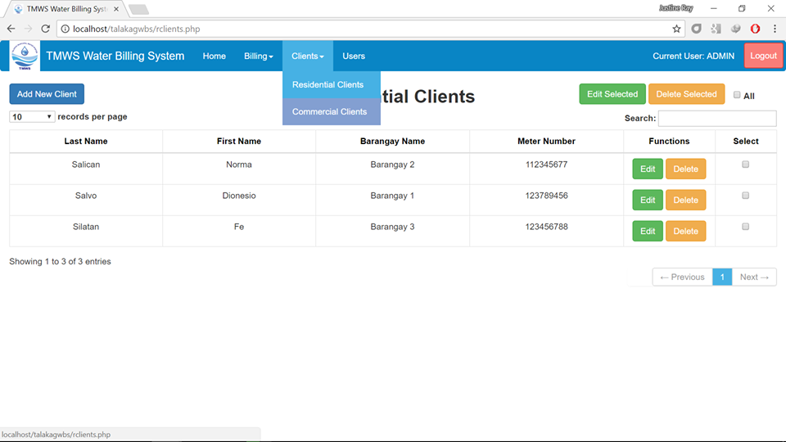

* A page will pop up, and enter the provided information.

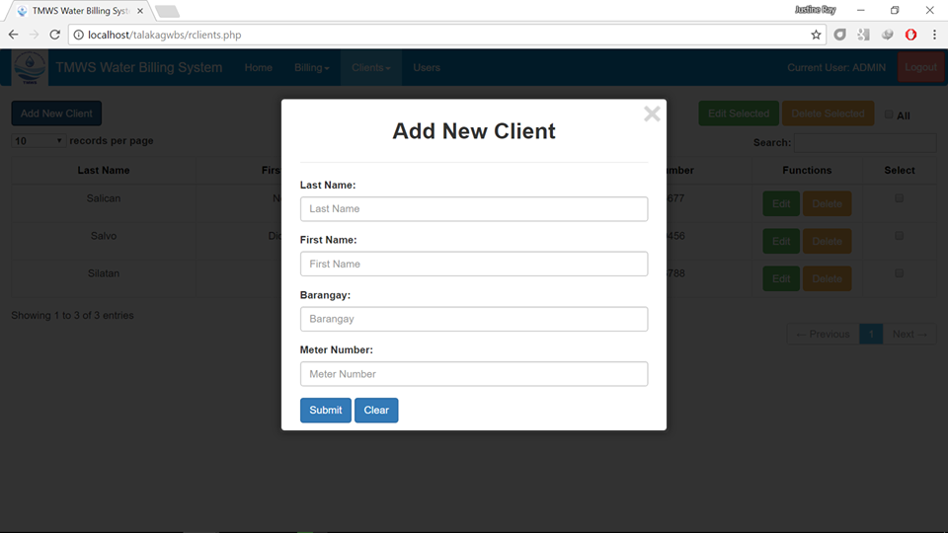

* And click on “Submit”.



* 1. Commercial Client
* On adding clients , click on the “Add New Client” button found on the upper most part of the page.

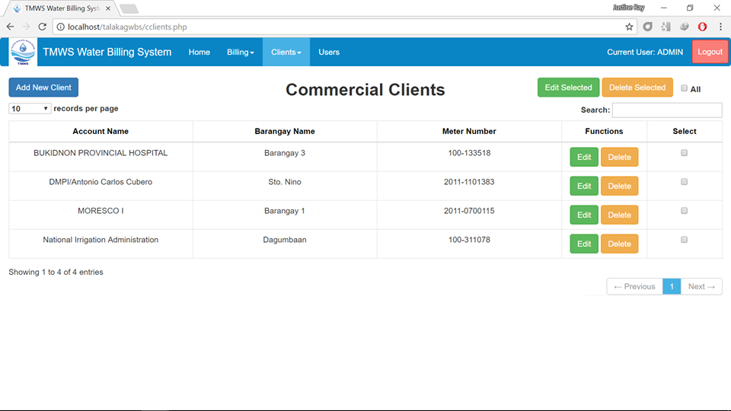

* A page will pop up, and enter the provided information.



* And click on “Submit”.



1. Edit Clients
   1. Residential Client

* On editing clients, click on the “Edit” button found in the Functions table.



* If the user wishes to edit some of the information, click on the boxes found on the Select table and click on the “Edit Selected”.





* 1. Commercial Client
* On editing clients, click on the “Edit” button found in the Functions table.



* If the user wishes to edit some of the information, click on the boxes found on the Select table and click on the “Edit Selected”button.





1. How to Delete Client
   1. Residential Client

* On deleting clients, click on the “Delete” button found in the Functions table.



* If the user wishes to delete some of the information, click on the boxes found on the Select table and click on the “Delete Selected” button.





* 1. Commercial Client
* On deleting clients, click on the “Delete” button found in the Functions table.



* If the user wishes to delete some of the information, click on the boxes found on the Select table and click on the “Delete Selected” button.





1. User Page

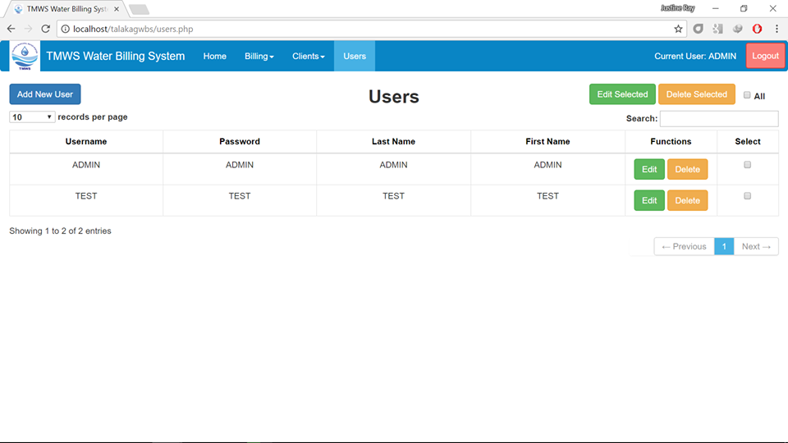

* 1. How to add Users

On adding users , click on the “Add New User” button found on the upper most part of the page.



* A page will pop up, and enter the provided information.

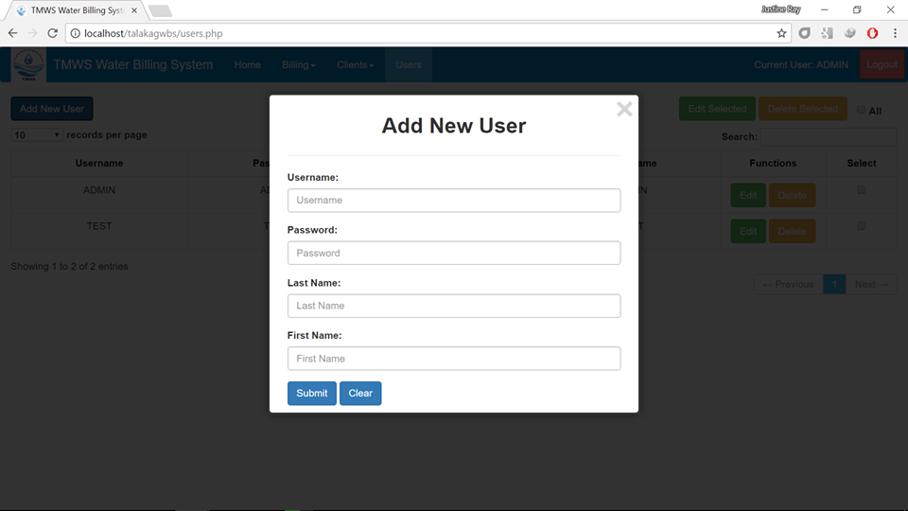

* And click on “Submit”.



* 1. Edit User
* On editing users, click on the “Edit” button found in the Functions table.



* If the user wishes to edit some of the information, click on the boxes found on the Select table and click on the “Edit Selected”button.





* 1. How to Delete Users
* On deleting users, click on the “Delete” button found in the Functions table.



* If the user wishes to delete some of the information, click on the boxes found on the Select table and click on the “Delete Selected” button.





* + 1. **Logout**

Logout option allows you to logout of the package, if you are logged in. The Logout option is available on the main screen in the top-section

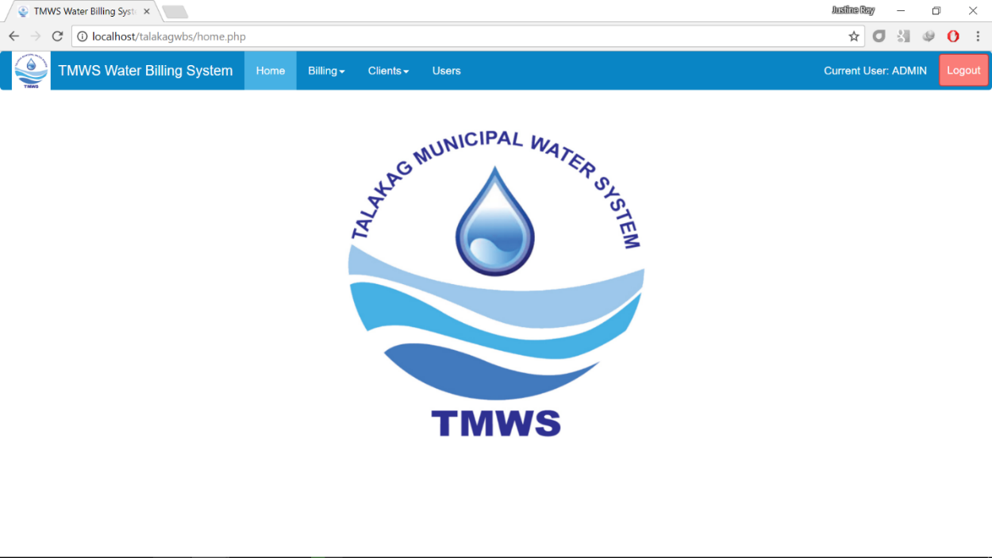

**XAVIER UNIVERSITY – ATENEO DE CAGAYAN**

**COLLEGE OF COMPUTER STUDIES**

c**DEPARTMENT OF INFORMATION SYSTEMS**

**TMWS WATER BILLING SYSTEM**

A Project Presented to the Faculty of the

Department of Information Systems

College of Computer Studies

In Partial Fulfillment of the Requirement for the Course

ISc 34

by:

Lamique, Christian

Gallardo, Gian

Nocete, Tristan

Olinan, Uenice

Pelayo, John

Prejan, Christian

Quidong, Paul

Santos, Maria

Sara, Maryl

Sherry, Ronald

Baclayo, Harry

Baconga, Justine

Casinillo, Adrian

Faciolan, Jeffrey

Fuentes, Roniel